Rotary Club of Kathmandu Mid-Town
Breakfast Chatter




10 February 2012 The Weekly Bulletin of Rotary Club of Kathmandu Mid-Town Bc-2.10/011-12

District: 3292 Web: www.rotarymidtown.org.np Club Id : 26776

FEBRUARY IS WORLD UNDERSTANDING MONTH
Advancing world understanding and peace, which is expressed in the fourth part of the Object of Rotary,
is an important focus of Rotarian service. It is the impetus for numerous service efforts and other cooperative ventures among Rotarians from different parts of the world. It is the reason Rotary International has a longstanding, close collaboration with the United Nations and many of its member agencies.
Appropriately, every year the anniversary of the founding of Rotary, 23 February, is celebrated as World Understanding and Peace Day..

3 February, Friday:
In-house Speaker PP Mani Joshi discussed the basics of the Rotary Foundation and elaborated on how it’s playing pivotal role in helping service projects worldwide. The speaker basically laid out two major keys for sustaining the Rotary as an organization – participating in service projects and contributions to TRF.
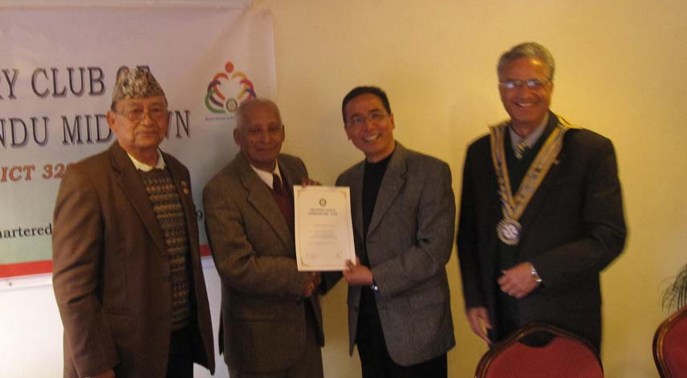
In-house Speaker PP Mani receiving certificate of appreciation from PP Giridhar
while President Som and Assistance Governor Phatte pose for Camera.

Weekly Meetings and Programs :
Date | Program/Speaker | Program/Topics of Presentation
10 February 2012 | Dr Yogendra Bhakta | Spiritualism: Shivapuri Baba
17 February 2012 | Dr. Suman Thapa | Glaucoma / Healthy eyes

Future Vision Plan:
T he mission of The Rotary Foundation is to enable Rotarians to advance world understanding, goodwill, and peace through the improvement of health, the support of education, and the alleviation of poverty.
The Foundation is a not-for-profit corporation supported solely by voluntary contributions from Rotarians and friends of the Foundation who share its vision of a better world.
Halfway through the three-year pilot of the Future Vision Plan, Rotarians are designing innovative projects and providing valuable feedback that will help improve The Rotary Foundation's new grant-making model.
Rotary Foundation Trustee Chair William B. Boyd shared these and other highlights from the pilot during the International Assembly -- an annual training meeting for incoming district governors -- this week in San Diego, California, USA.
"We are on a Future Vision journey that will lead us to a new Foundation," said Boyd, noting that "we are well on the way."
Boyd said Future Vision is built on the principles of simplicity and sustainability, and a desire to involve districts, clubs, and Rotarians more in spending and stewardship.
Under Future Vision, the number of grant types is being streamlined from 12 to just two: global grants and district grants. Global grants support large international activities with sustainable impact in one or more of the six areas of focus. District grants can be used for a wide range of activities that align with the Foundation's mission.
All districts will begin using the new model on 1 July 2013. Boyd said that concentrating on the six areas of focus has been one of the chief advantages of the plan.
“We needed to lift ourselves above the multitude of little projects that felt good but addressed symptoms, not causes, and were too short-term in their benefits," he said. "We have finite resources and cannot do everything for everybody, but these are key areas in which Rotarians can make a difference. We can change the world."
Boyd described the service activities of District 5020 (parts of British Columbia, Canada, and Washington, USA), one of the 100 districts participating in the Future Vision pilot. Through a dozen global grants, district Rotarians have supplied schools in Kenya with books in English and Swahili, installed solar panels at schools in Peru and the Philippines, and furnished classrooms and washrooms at a vocational and literacy school in Honduras.
"We are seeing Future Vision re-energizing clubs, so that they are breaking from the cycle of doing last year’s projects this year and again next year," Boyd said.
Boyd told incoming district governors that they can prepare for the global launch of Future Vision by closing old Matching Grant reports so they can focus on new projects, and by tapping resources like the regional Rotary Foundation coordinators. He also encouraged them to think big, to keep pushing boundaries, and to avoid trying to fit old procedures into the new model.
We are here to serve, and each one of us is a Rotarian because we know that our lives are measured by what we do for others and not by what we do for ourselves," he said.
During the assembly’s third plenary session, Trustee Chair-elect Wilfrid J. Wilkinson also set out the Foundation's goals for 2012-13, which are eradicating polio, achieving Peace Through Service , strengthening the Foundation through the Annual Fund, and providing good stewardship of Foundation funds at the district level.
Source: Megan Ferringer/Rotary International News

Participation in RYLA :
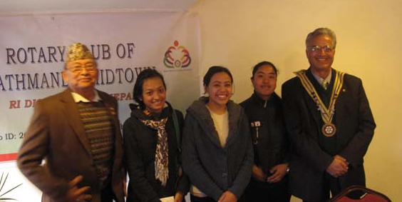
AG Phatte and President Som with 3 Rotaracts/Interacts who will be participating
in RYLA beginning today (3-6 Feb ‘012) in Dhulikhel

District Team Training Seminar:
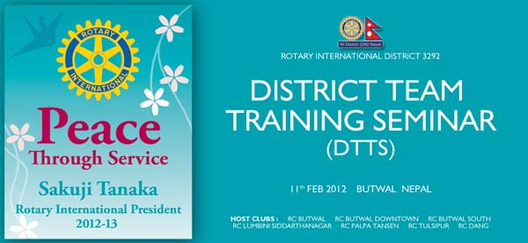

The 5th District Governor of RI District 3292 (2012-013 )
Rtn Yogendra Pradhan has appointed Assistant Governors for
19 zones and 14 District committee chairs with sub-committee
chairs and members .
The District Team Training Seminar 2012-13 (DTTS ) is being
conducted for 2012-13 team leaders at Butwal on 11 Feb 2012
(Saturday) with all the 8 clubs of Zone 15 as the host and
with President Rajendra Dhoju of RC Butwal as the main
coordinator.

As leaders, we are like caring gardeners who tend their flower beds with love and care and
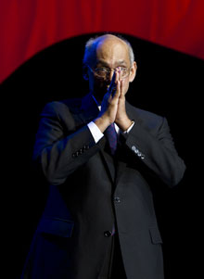
firmness, all at the same time enabling the seed of talent and capability to germinate and
grow to bear great flowers and fruits while preventing the weeds of selfishness or
indifference from taking root.
RI President Kalyan Banerjee

Now you can eat 2 years old sandwich !
A sandwich that stays fresh for two years has been developed for the US Army. Food scientists created the long-lasting snack using ingredients that can keep moisture trapped inside them, like honey, salt and sugar. That’s important because the bacteria that decays food needs water to grow. So by keeping its moisture, the sandwich holds off the bacteria and it stays fresh and tasty to eat. So by keeping its moisture, the sandwich holds off the bacteria and it stays fresh and tasty to eat.
Source: The Himalayan Times

On Lighter Side : Click here ⇩


A thought for the day:
A person without a sense of humor is like a wagon without springs –
jolted by every pebble in the road !
- Henry Ward Beecher


Tsunami Japan cruel Nature photos

Please send project/activity information, suggestions and photos etc to :
BC Editor: RR Shrestha email: rryes@wlink.com.np

10 February 2012 The Weekly Bulletin of Rotary Club of Kathmandu Mid-Town bc-2.10/011-12

